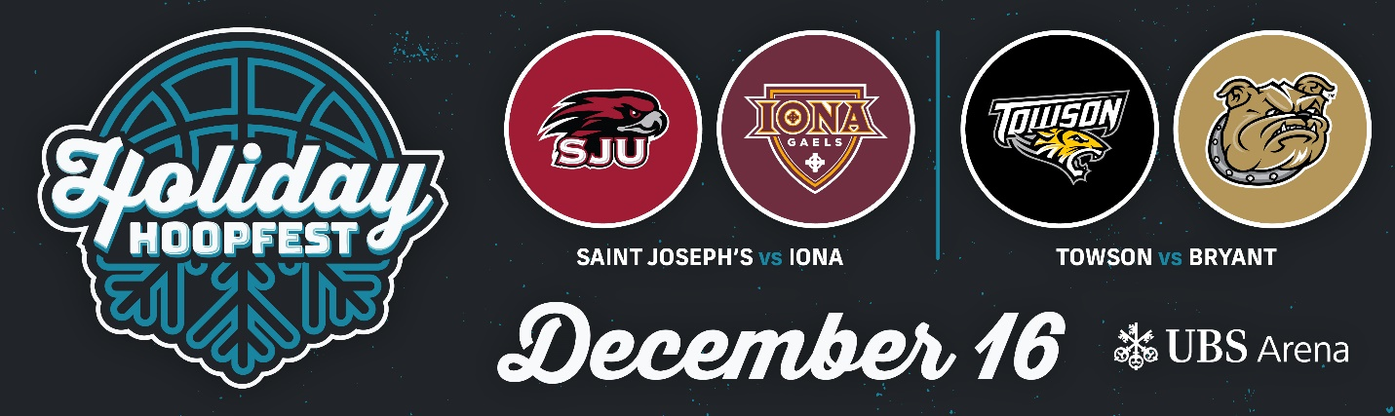
2023 HOLIDAY HOOPFEST FIELD AND MATCHUPS ANNOUNCED

FOR IMMEDIATE RELEASE
July 27, 2023
PRINCETON, N.J. – Saint Joseph’s, Iona, Towson, and Bryant will compete in the 2023 Holiday Hoopfest at UBS Arena at Belmont Park, located 30 minutes from Penn Station or Grand Central via LIRR, on December 16th, 2023.
Saint Joseph’s – Head Coach: Billy Lange (Atlantic 10)
The Hawks come off their best season under Billy Lange, finishing 16-17 overall. All Conference guard Erik Reynolds II returns to Hawk Hill where he led the team in three pointers made (99) and points per game (19.6). He ranks among the top-15 returning scorers in the nation heading into 2023-24.

Iona – Head Coach: Tobin Anderson (Metro Atlantic Athletic Conference)
Iona recently hired Tobin Anderson, who led Fairleigh Dickinson to the second-ever 16-seed-over-1-seed victory in NCAA Tournament history during his inaugural Division I coaching season last March. The leadership change in New Rochelle has sparked a restocking of the Gaels' roster with Anderson bringing in 11 newcomers in support of the program's lone returner, Osborn Shema.

Towson – Head Coach: Pat Skerry (Coastal Athletic Association)
The Tigers come off back-to-back twenty plus win seasons including a first-place finish in the CAA and birth to the NIT in 2021-22. Two-time All-CAA forward Charles Thompson returns, averaging 12.2 points and eight rebounds a game last season.

Bryant – Head Coach: Jared Grasso (American East Conference)
Head Coach Jared Grasso led the Bulldogs to a 17-13 record in their first year in the America East Conference. In 2021-22 he led Bryant to their first ever NCAA Tournament appearance.

Below are the matchups for the event:
Saturday, December 16
Saint Joseph’s vs. Iona
Towson vs. Bryant

Television coverage, additional games, and the public on-sale date for tickets will be announced at a later date.
To be the first to receive updates on these important details sign up for Gazelle Ticket Updates and follow us on Twitter @HoliHoopfest and Instagram @HoliHoopfest.

About the Gazelle Group
The Gazelle Group is a sports marketing firm, specializing in event production and management, client representation, and sponsorship consulting. Gazelle produces numerous nationally recognized college sports events, such as the Empire Classic, Legends Classic, Gotham Classic, Sunshine Slam, College Basketball Invitational, Kwik Trip Holiday Face-Off, Barstool Sports Invitational as well as on-campus events at Duke, Kentucky, Nebraska, and other institutions across the country. For more information on the Gazelle Group, please visit gazellegroup.com and follow us on Twitter @Gazelle_Events.

About UBS Arena
UBS Arena at Belmont Park is made for music and built for hockey. New York's newest premier entertainment and sports venue and home of the New York Islanders is developed in partnership with Oak View Group, the New York Islanders, and Jeff Wilpon. The state of the art arena opened in November 2021 and has welcomed numerous top artists including Harry Styles, Sebastian Maniscalco, Billie Eilish, Dua Lipa, TWICE, Eagles, John Mayer, Kendrick Lamar and Post Malone. The venue delivers an unmatched live entertainment experience for guests including clear sightlines and premier acoustics.
UBS Arena is at the forefront of sustainability, being awarded LEED Green Building Certification in January 2023. The venue also achieved carbon neutrality for operations in Fall 2022 which made it the first arena to do so on the eastern United States seaboard. For more information on the venue’s sustainability efforts, please visit UBSArena.com/sustainability.
Located on the historic grounds of Belmont Park, UBS Arena is located just 30 minutes by LIRR from Grand Central or Penn Station and is easily accessible from across the region via mass transit or car. To plan your trip, please visit UBSArena.com/plan-your-trip.
For additional information, please visit UBSArena.com or @UBSArena on Facebook, Instagram and Twitter.

