MEDIA CONTACT: Meg Stagaard / 42West
Meg.Stagaard@42west.com; 973-951-4577

Your Favorite Disney Characters Return to Belmont Park!

Disney On Ice presents Mickey’s Search Party
Brings the Magic to Fans at UBS Arena
Through Innovative Technology and Transformative Performances
from January 15-19, 2026
Belmont Park, NY (August 5, 2025) - Disney On Ice presents Mickey’s Search Party is bringing the magic to guests through dynamic moments that take place on the ice and in the air. This adventure delivers compelling storytelling through multi-leveled production numbers so be prepared to join this magical search and help unlock an epic journey when Disney On Ice presents Mickey’s Search Party delivers an unforgettable experience at the UBS Arena from January 15-19, 2026.
- Disney On Ice Preferred Customers can purchase advance tickets starting today to get the best seats available before tickets go on-sale to the general public on August 12. Fans can still sign up to become a Disney On Ice Preferred Customer and get exclusive access to the pre-sale offer code.
Embark on a quest with Mickey Mouse and pals as they follow Captain Hook’s treasure map for clues to find Tinker Bell after he attempts to capture her magic. Journey across the Marigold Bridge with Miguel from Disney●Pixar’s Coco into the magnificent and mystical Land of the Dead and discover a vibrantly colorful performance with skeletons atop sway poles dancing over the audience in a beautiful cultural celebration of family. Travel to the wintry world of Arendelle and sing along with Elsa as video projection creates a kaleidoscope of crystals to help build her ice palace. Witness Belle lift into the sky as the enchanted chandelier comes to life high over the ice. Demonstrate the power of teamwork when Buzz Lightyear, Woody and Jessie recruit the Green Army Men for a daring rescue in Andy’s room. Laugh hysterically as the hilarious pirates flip, tumble, and twist on tumble tracks, stilts and more in an effort to showcase their talents for Captain Hook. Sail away with Moana on her daring voyage across the ocean and bravely encounter the fiery wrath of Te Ka. And make memories with your whole family during Aladdin and The Little Mermaid as the search party becomes an all-out magical celebration.

Click here to view Mickey's Search Party Show Trailer
WHEN: Thursday, January 15 7:00 PM
Friday, January 16 7:00 PM
Saturday, January 17 11:00 AM, 3:00 PM & 7:00 PM
Sunday, January 18 12:00 PM & 4:00 PM
Monday, January 19 12:00 PM

WHERE: UBS Arena - 2400 Hempstead Turnpike, Belmont Park, NY 11003

TICKETS: Family friendly ticket pricing available – tickets can be purchased online at Ticketmaster.com or in-person at the venue Box Office.
*Ticket pricing is subject to change based on market demand.

MEDIA PHOTOS/VIDEO: Members of the media can visit here for hi-res show photos
and broadcast quality show performance video.

Online/Social Media Content: Exclusive Behind the Scenes multimedia packages/making-of featurettes can be viewed & downloaded here

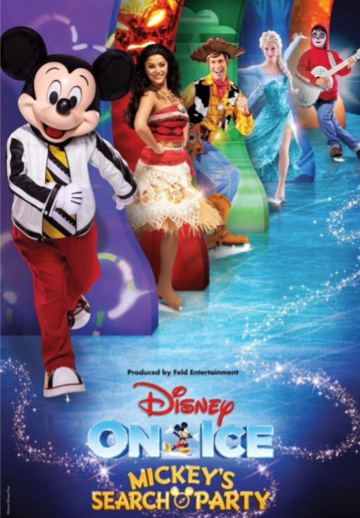

For local Belmont Park event info please visit
https://www.disneyonice.com/mickeys-search-party/belmont-park-ny-ubs-arena

Follow Disney On Ice social media channels: Facebook, Twitter & Instagram.
Subscribe to the Disney On Ice YouTube Channel at www.youtube.com/DisneyOnIce

###

About Feld Entertainment
Feld Entertainment®, family owned and operated, is the worldwide leader in producing and presenting live touring family entertainment experiences that bring people together and uplift the human spirit. Properties include Ringling Bros. and Barnum & Bailey®, Monster Jam®, Disney On Ice, Monster Energy AMA Supercross, and the SuperMotocross World Championship. Across the brand portfolio, Feld Entertainment has entertained millions of families in more than 80 countries and on six continents. Visit feldentertainment.com for more information.

