ROMEO SANTOS AND PRINCE ROYCE ANNOUNCE ADDITIONALTOUR DATES FOR THEIR “MEJOR TARDE QUE NUNCA” TOUR 2026 DUE TO OVERWHELMING DEMAND INCLUDING UBS ARENA ON APRIL 19
Tickets On Sale Now via Ticketmaster
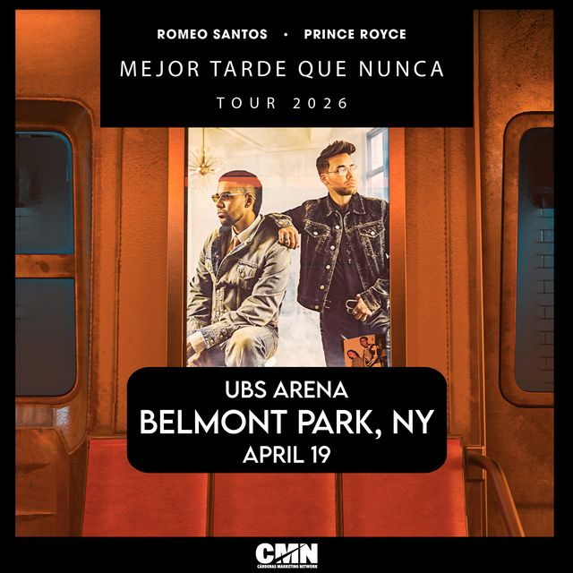

(Chicago, IL) – Following unprecedented demand and multiple sold-out shows, the King and Prince of Bachata, Romeo Santos and Prince Royce announce additional tour dates to their MEJOR TARDE QUE NUNCA U.S. Tour 2026 including April 19 at UBS Arena in Belmont Park, NY., produced by Cardenas Marketing Network (CMN).
The tour will showcase the duo’s new music alongside the chart-topping hits that have defined their respective careers, offering fans a historic live experience of Bachata royalty that unites two icons whose music has defined generations. This tour marks a defining moment in bachata history that fans won’t want to miss.
The tickets for the additional dates are now on sale. For more information, dates, and tickets, please visit: http://cmnevents.com/

# # #

For press inquiries:
Jen Espinoza, CMN PR Coordinator : jespinoza@cmnevents.com
Kerry Graue, UBS Arena - Senior Director, Public Relations : kerry.graue@ubsarena.com

About Cardenas Marketing Network (CMN):
CMN is the leader in live entertainment. As a touring, booking, sports and multicultural marketing agency, our goal is to entertain by creating unique experiences through our events. Henry Cárdenas, entrepreneur, philanthropist, and founder of CMN, is a pioneer in bringing Latin entertainment and live sport events to the United States. The Chicago-based company with offices in Miami operates through professionals constantly creating cutting-edge experiences and producing the best events in the country. To learn more about CMN and its roster of artists, visit www.cmnevents.com or follow us at @cmnevents.

About UBS Arena
Located in the heart of the expanding experiential destination of Belmont Park, UBS Arena is New York’s newest premier live entertainment and sports venue. Proud home to the New York Islanders, the state-of-the-art arena was developed in partnership with Oak View Group, the New York Islanders and Jeff Wilpon, and has welcomed over 3 million guests and 350+ events with top artists from around the world since November 2021.
Built with fan-first amenities, inspired by the timeless elegance of New York and powered by state-of-the-art technology, the venue is made for music and built for hockey with clear sightlines and premier acoustics. UBS Arena is at the forefront of sustainability, achieving Zero Waste TRUE Silver certification in addition to its LEED Green Building Certification and carbon neutrality for operations.
UBS Arena is located just 30 minutes by LIRR from Grand Central or Penn Station and is easily accessible from across the region via mass transit or car. To plan your trip, please visit UBSArena.com/plan-your-trip. Keep in touch with us at UBSArena.com/updates or @UBSArena on Facebook, Instagram and X/Twitter.

