BARRY MANILOW ADDS NORTHEAST TOUR DATES TO 2026 ARENA TOUR

BELMONT PARK, NY - APRIL 13
NEWARK, NJ - APRIL 14
WILKES-BARRE, PA - APRIL 16
READING, PA - APRIL 17
PORTLAND, ME - APRIL 19
ALBANY, NY - APRIL 20
BUFFALO, NY - APRIL 22

MANILOW MUSIC TEACHER AWARDS ALSO ANNOUNCED;
VOTING OPENS FEBRUARY 19

NEW SINGLE “ONCE BEFORE I GO” CONTINUES TO CLIMB THE CHARTS; PIANO PERFORMANCE VIDEO OUT NOW - WATCH HERE

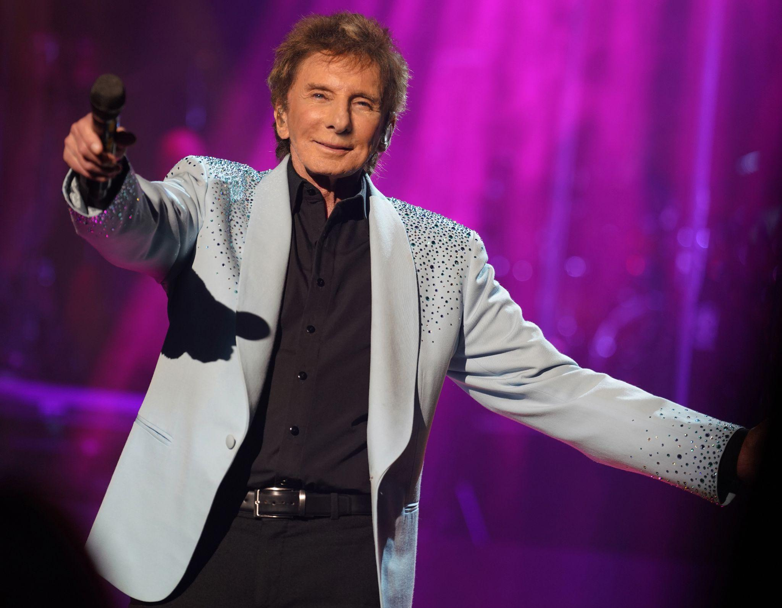
Photo credit: Dana Holland

January 27, 2026: Barry Manilow has announced seven new arena dates on his 2026 tour, extending the run into April with additional performances across the Northeast. The GRAMMY®, TONY®, and EMMY® Award-winning icon will bring his celebrated live show to New York (Long Island, Buffalo, Albany), New Jersey (Newark), Pennsylvania (Wilkes-Barre, Reading), and Maine (Portland), marking his final concerts in seven newly-announced cities. The announcement marks the beginning of what is shaping up to be a big year for Manilow, with new music expected in 2026.

Artist presale for the April dates begins Wednesday, January 28th at 10:00am until Thursday, January 29th at 10:00pm local. Local and partner presales open on Thursday, January 29th at 10:00am until 10:00pm local. All tickets are on sale Friday, January 30th at 10:00am local.

At every show, Manilow will celebrate local music educators with the Manilow Music Teacher Award. Created through the Manilow Music Project, a program of the Manilow Fund, the Manilow Music Teacher Award honors educators whose passion and dedication help bring music to life for their students. Nominees will be revealed on February 19, the same day voting opens. The teacher receiving the most online votes will be recognized during Manilow’s concert and will receive a total prize of $10,000 - a $5,000 cash award and $5,000 in “Manilow Bucks” for classroom instrument purchases. Voting closes on March 19.

In addition to celebrating each Manilow Music Teacher Award winner during the upcoming shows, audiences can expect an unforgettable evening as Manilow performs his greatest hits, including “Mandy,” “I Write the Songs,” “Looks Like We Made It,” “Can’t Smile Without You,” and “Copacabana (At the Copa).” With his signature showmanship and timeless catalog, each performance will be a once-in-a-lifetime celebration with one of music’s most legendary performers.

Manilow recently released a new single “Once Before I Go,” which continues to climb up the AC chart (currently #13). Today, he has unveiled a piano performance video of the song, filmed at the Westgate Las Vegas Resort & Casino, home to Manilow’s record-setting and critically-acclaimed residency. Watch the new piano performance HERE.

Last month, Manilow announced a stage-one lung cancer diagnosis (statement here) before undergoing surgery. Thanks to the early detection, the operation went well and his medical team is optimistic. Manilow’s previously-announced January tour dates have been rescheduled for March and April. Please find all arena tour dates below and visit https://barrymanilow.com/ for tickets, VIP packages, and more information.

Barry Manilow 2026 Arena Shows
February 27 – Tampa, FL - Benchmark International Arena
March 1 – Charlotte, NC – Spectrum Center
March 2 – Norfolk, VA – Chartway Arena
March 3 – Baltimore, MD – CFG Bank Arena
March 5 – Cincinnati, OH – Heritage Bank Center
March 6 – Columbus, OH – Nationwide Arena
March 7 – Nashville, TN – Bridgestone Arena
March 9 – Lexington, KY – Rupp Arena
March 11 – Charleston, SC – North Charleston Coliseum
March 13 – Orlando, FL – Kia Center
March 14 – Sunrise, FL – Amerant Bank Arena
March 16 & 17 – Estero, FL – Hertz Arena
April 13 – Belmont Park, NY – UBS Arena
April 14 – Newark, NJ – Prudential Center
April 16 – Wilkes-Barre, PA – Mohegan Arena at Casey Plaza
April 17 – Reading, PA – Santander Arena
April 19 – Portland, ME – Cross Insurance Arena
April 20 – Albany, NY – MVP Arena
April 22 – Buffalo, NY – KeyBank Center
April 24 – Greensboro, NC – First Horizon Coliseum
April 27 – Jacksonville, FL – VyStar Veterans Memorial Arena
April 29 – Duluth, GA – Gas South Arena

About Barry Manilow
With a career spanning more than five decades, Barry Manilow has become one of the most celebrated entertainers in history. Named the #1 Adult Contemporary Artist of all time by Billboard and R&R magazines, he has sold more than 85 million albums worldwide, released over 40 albums, and earned 51 Top 40 singles, including 13 #1s and 28 Top 10 hits. A Songwriters Hall of Fame inductee, Manilow has earned GRAMMY®, TONY®, and EMMY® Awards and has been honored with the BMI Icon Award.

His long-running Las Vegas residency has been hailed among the city’s best, and his record-breaking appearances at Radio City Music Hall cement his place as one of the venue’s all-time greats. In addition to his recording and touring success, Manilow’s original Broadway musical Harmony was named a 2023 New York Times Critic’s Pick, further underscoring his enduring creativity. Beyond the stage, he founded the Manilow Music Project, which has donated millions of dollars in instruments and resources to schools across the country, ensuring future generations have access to music education.

In April 2026, Manilow will be presented with the American Advertising Federation (AAF)'s 2026 prestigious President’s Award at the AAF's Advertising Hall of Fame induction ceremony for his incredible work in advertising. Manilow has produced, composed, and performed some of the most iconic commercial jingles of all time for companies and brands such as State Farm, Band-Aid, KFC, Pepsi, McDonald’s and more.

For more information on Barry Manilow, please contact:
Allison Elbl & Taylor Perry at Shore Fire Media

