INTERNATIONAL SUPERSTAR LIONEL RICHIE AND LEGENDARY MUSICAL POWERHOUSE EARTH, WIND & FIRE ANNOUNCE 2026 NORTH AMERICAN TOUR INCLUDING UBS ARENA ON JULY 14
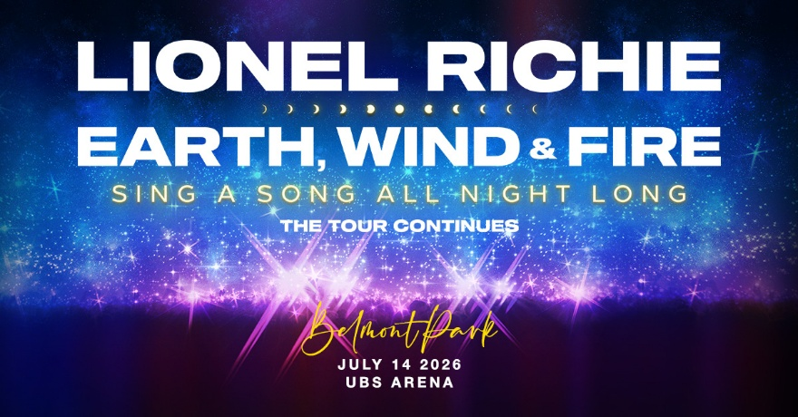

Tickets Available Starting on Tuesday, January 27 with Citi Presale;
General On-Sale Begins on Friday, January 30 at 10 am at LiveNation.com
For approved artist images and hi-res tour art, please download HERE.

Today, legendary singer, songwriter and producer Lionel Richie and one of the best-selling bands of all time, Earth, Wind & Fire announce their 2026 North American Tour. Produced by Live Nation, the 26-city tour includes a stop at UBS Arena in Belmont Park, NY, on July 14, 2026.
TICKETS: Tickets will be available starting with Citi presale (details below) beginning on Tuesday, January 27 at 10 am. Additional presales will run throughout the week ahead of the general on-sale beginning on Friday, January 30 at 10 am at LiveNation.com.
PRESALE: Citi is the official card of Lionel Richie and Earth, Wind & Fire 2026 Tour. Citi cardmembers will have access to presale tickets beginning Tuesday, January 27 at 10 am until Thursday, January 29 at 10 pm through the Citi Entertainment program. For complete presale details visit www.citientertainment.com.
VIP: The tour will also offer a variety of different VIP packages and experiences for fans to take their concert experience to the next level. Packages vary but include premium tickets, access to the pre-show VIP Lounge, limited edition tour poster, specially designed VIP gift item and more. For more information, visit vipnation.com.
Lionel Richie’s show is created in partnership with Brian Burke Creative.

LIONEL RICHIE AND EARTH, WIND & FIRE 2026 TOUR DATES:
Wed Jun 24 – St. Paul, MN – Grand Casino Arena
Fri Jun 26 – Chicago, IL – United Center
Sat Jun 27 – Columbus, OH – Schottenstein Center
Tue Jun 30 – Pittsburgh, PA – PPG Paints Arena
Wed Jul 01 – Detroit, MI – Little Caesars Arena
Sat Jul 04 – Toronto, ON – Scotiabank Arena
Sun Jul 05 – Montreal, QC – Bell Centre
Wed Jul 08 – Boston, MA – TD Garden
Fri Jul 10 – Hartford, CT – PeoplesBank Arena
Sat Jul 11 – New York, NY – Madison Square Garden
Tue Jul 14 – Belmont Park, NY – UBS Arena
Thu Jul 16 – Philadelphia, PA – Xfinity Mobile Arena
Sat Jul 18 – Greensboro, NC – First Horizon Coliseum
Sun Jul 19 – Atlanta, GA – State Farm Arena
Wed Jul 22 – Tampa, FL – Benchmark International Arena
Fri Jul 24 – Hollywood, FL – Hard Rock Live at Seminole Hard Rock Hotel & Casino
Sat Jul 25 – Orlando, FL – Kia Center
Tue Jul 28 – San Antonio, TX – Frost Bank Center
Wed Jul 29 – Dallas, TX – American Airlines Center
Fri Jul 31 – Denver, CO – Ball Arena
Mon Aug 03 – Seattle, WA – Climate Pledge Arena
Thu Aug 06 – San Francisco, CA – Chase Center
Sat Aug 08 – Palm Desert, CA – Acrisure Arena
Sun Aug 09 – Los Angeles, CA – Intuit Dome
Tues Aug 11 – Phoenix, AZ – Mortgage Matchup Center
Fri Aug 14 – Austin, TX – Moody Center

ABOUT LIONEL RICHIE
International superstar Lionel Richie boasts a discography of albums and singles that is second to none. With more than 125 million albums sold worldwide, an Oscar®, Golden Globe®, and four Grammy Awards®, Richie has been honored with distinctions including 2016 MusiCares Person of the Year, and the 2017 Kennedy Center Honors. In March 2018, Richie cemented his iconic legacy as he imprinted his hand and footprints at Hollywood’s storied TCL Chinese Theatre. In 2022, he was both inducted into the Rock & Roll Hall of Fame and received the 2022 American Music Awards Icon Award, his 18th AMA award. He also received the 2022 Gershwin Prize for Popular Song by the Library of Congress. Richie debuted and served as producer on the documentary The Greatest Night in Pop, which premiered at the 2024 Sundance Film Festival to critical acclaim. The Greatest Night in Pop quickly became a cultural phenomenon as the most watched music documentary of 2024 with a staggering 1.3 billion minutes viewed. Richie has served as a judge on ABC's "American Idol" for the past eight seasons and is back for its 9th season. He also served as executive producer on AppleTV+’s “KPOPPED,” which hit #1 in South Korea and the top 10 in 99 countries. Most recently, Richie offered an intimate and candid reflection on his journey through music, fame, and personal transformation in his New York Times bestselling memoir Truly, released on September 30, 2025.

ABOUT EARTH, WIND & FIRE
Earth, Wind & Fire are a music institution. In 1969, music legend Maurice White birthed the music force named after the elements from his very own astrological charts. With soul as deep as the plant, Earth, Wind & Fire charted a history that will live on forever. They’ve scored eight number one hits and have sold more than 100 million albums worldwide. They’ve released 23 albums; eight of those albums went Double Platinum and hit the Top 10, making them one of the best-selling artists of all time. They've won an impressive nine GRAMMY® Awards including one for Lifetime Achievement (2012). In 2000, Earth, Wind & Fire was inducted into the Rock and Roll Hall of Fame, cementing their lasting impact on popular music and, in 2019, their contributions to arts and culture were acknowledged in Washington DC with the prestigious Kennedy Center Honors.

The music of Earth, Wind & Fire is more alive than ever as they continue to inspire new audiences and thrill those who have been with them from the beginning. Like the elements in their name, Earth, Wind & Fire’s music has withstood ever-changing trends in the world and shows no sign of vanishing as they continue to create joy and uplifting music that will forever reach a sacred universal atmosphere. From the funky and infectious “Let’s Groove” to the timeless dance classic “September” to the heartfelt “Reasons,” Earth, Wind & Fire’s catalog of hits has become the soundtrack to many lives; now, then and forever.

About UBS Arena
Located in the heart of the expanding experiential destination of Belmont Park, UBS Arena is New York’s newest premier live entertainment and sports venue. Proud home to the New York Islanders, the state-of-the-art arena was developed in partnership with Oak View Group, the New York Islanders and Jeff Wilpon, and has welcomed over 3 million guests and 350+ events with top artists from around the world since November 2021.
Built with fan-first amenities, inspired by the timeless elegance of New York and powered by state-of-the-art technology, the venue is made for music and built for hockey with clear sightlines and premier acoustics. UBS Arena is at the forefront of sustainability, achieving Zero Waste TRUE Silver certification in addition to its LEED Green Building Certification and carbon neutrality for operations.
UBS Arena is located just 30 minutes by LIRR from Grand Central or Penn Station and is easily accessible from across the region via mass transit or car. To plan your trip, please visit UBSArena.com/plan-your-trip. Keep in touch with us at UBSArena.com/updates or @UBSArena on Facebook, Instagram and X/Twitter.

MEDIA CONTACTS:

Lionel Richie
Jeff Raymond | jraymond@2pmsharp.com

Earth, Wind & Fire
Kristen Foster | kristen.foster@fullcov.com
Gabi Hollander | gabi.hollander@fullcov.com

Live Nation Concerts
Navier Grimes | naviergrimes@livenation.com

UBS Arena
Kerry Graue | kerry.graue@ubsarena.com

To apply for media credentials to the North American tour dates please visit: livenation.com/pressrequests

